**EXPERIMENT-4**

# AIM:

# Estimate the precision recall accuracy f-measure of the decision classifier on a breast cancer dataset using 10 fold cross validation.

# ALGORITHM:

1. Select the best attribute using Attribute Selection Measures (ASM) to split the records.
2. Make that attribute a decision node and breaks the dataset into smaller subsets.
3. Starts tree building by repeating this process recursively for each child until one of the conditions will match:
   1. All the tuples belong to the same attribute value.
   2. There are no more remaining attributes.
   3. There are no more instances.

# PROGRAM CODE SNIPPET:

## LOADING DATA SET:

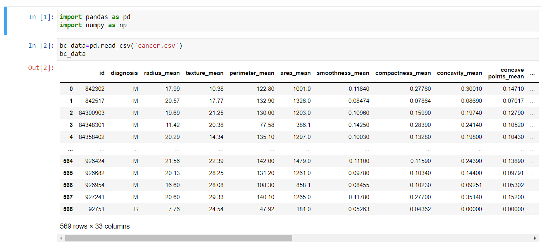

## PREPROCESSING:

## 

**ML ALGORITHM IMPLEMENTATION:**

